Creative Arts, Technology & Engineering
Module Title: | Final Year Project | Module Code: | COM6001
Assignment No/Title: | CW1 | Assessment Weighting: | 100%
Submission Date: | Wednesday 20thMay 2026 by 14:00 | Feedback Date: | + 3 Weeks
Module Tutor: | Justin Luker / Nicholas Day | Degree: | Degree
Student ID: | 22210878 | Student Name: | Raja Abdullah Shafique
1st Supervisor: | Dr. Shahadate Rezvy | 2nd Supervisor: | Dr. Shahadate Rezvy
Course: | BSc. (Hons) Computer Science Artificial Intelligence
Word Count: | 10000 Words

Plagiarism Statement:
I certify that this CW1 Final Year Project COM6001 report is my own work, based on my personal study and/or research and that I have acknowledged all material and sources used in its preparation, whether they be books, articles, reports, lecture notes, and any other kind of document, electronic or personal communication. I also certify that this Final Year Project COM6001report has not previously been submitted for assessment in any other module or course of study, except where specific permission has been granted from all supervisors involved, and that I have not copied in part or whole or otherwise plagiarised the work of other students and/or persons.
Print Full Name: | Raja Abdullah Shafique | Date: | 19th May 2026
Signature (electronic): | Abdullah

Pathway B
Github Repository Link: https://github.com/rajaad725/Hybrid_AI_Breast_Cancer_Detection
Project Title (Approx. 50 Words):
Hybrid Artificial Intelligence for Breast Cancer Detection Using Clinical and Mammographic Image Data: A Multimodal Machine Learning Approach
Acknowledgments (Approx. 50 Words):
I would like to express my sincere gratitude to my supervisor Dr. Shahadate Rezvy for their continuous guidance, support, and valuable feedback throughout this project. I also thank other lecturers especially Dr. Nicholas Day for providing the foundational knowledge required for this research. Finally, I appreciate my family and friends for their encouragement and support during this journey.
Abstract (Approx. 150 Words):
This project investigates the application of hybrid artificial intelligence techniques for breast cancer detection through the integration of clinical features and mammographic imaging data. Three experimental baselines were developed and evaluated: a traditional machine learning baseline using clinical data, a deep learning baseline using mammographic images, and a multimodal baseline combining both modalities through late fusion. The study utilized the TOMPEI-CMMD dataset obtained from The Cancer Imaging Archive (TCIA). Data preprocessing involved image conversion, dataset cleaning, patient-level splitting to prevent data leakage, and alignment of imaging and clinical records. Multiple models including Logistic Regression, Random Forest, Support Vector Machine, ResNet18, EfficientNet-B0, and a custom multimodal neural network were implemented and evaluated using accuracy, precision, recall, F1-score, confusion matrices, ROC curves, and threshold analysis. Experimental results demonstrated that the multimodal approach achieved stronger balanced classification performance compared with image-only deep learning models, particularly for minority-class detection. The findings highlight the potential of multimodal artificial intelligence systems for improving robustness and reliability in computer-aided breast cancer diagnosis.

Table of Contents (Unlimited Words):
Acknowledgments (Approx. 50 Words): 4
Abstract (Approx. 150 Words): 5
Introduction (Approx. 250 Words): 7
Background (Approx. 200 Words): 7
Rationale (Approx. 200 Words): 8
Ethical Considerations (Approx. 200 Words) 8
Aim (Approx. 50 Words): 8
Objectives (Approx. 150 Words): 9
Risks (Approx. 250 Words): 10
Literature Survey (Approx. 1550 Words): 11
Methodology (Approx. 850 Words): 13
Data Collection (Approx. 1500 Words): 15
Data Analysis (Approx. 1550 Words): 17
Discussion (Approx. 2000 Words): 22
Conclusions (Approx. 500 Words): 32
Recommendations for Further Work (Approx. 500 Words): 33
Glossary (Unlimited Words): 34
References (Unlimited Words): 35
Bibliography (Unlimited Words): 36
Appendix A: Project Plan (Unlimited Words): 37
Appendix B: Ethics Checklist (Unlimited Words): 39
Appendix C: Participant Consent Form (Unlimited Words): 41

Introduction (Approx. 250 Words):

Breast cancer is one of the most common and fatal diseases among women in the world. Approximately 2.3 million new cases of breast cancer are detected every year, and a large number of deaths are associated with the late diagnosis (Arravalli et al., 2025). Therefore, early and correct diagnosis is critical for better survival rates and decreasing the strain on healthcare systems. Traditional diagnosis procedures rely mainly on the clinical diagnosis and imaging techniques such as mammography. However, these techniques are subjected to human interpretation, variability and low sensitivity in complex cases (Hanis, Islam and Musa, 2022).

In recent years, artificial intelligence (AI) has become an increasingly effective tool in medical diagnostics, able to analyze complicated patterns in both clinical and imaging data. Machine learning and deep learning models have demonstrated excellent outcomes in breast cancer detection, frequently offering more consistency and efficiency than older methods (Geng, 2025). These techniques enable the automated extraction and classification of features, aiding doctors to make better informed and correct decisions.

Despite these developments, many existing systems are focused on a particular data modality, such as clinical or imaging data, which may limit their predictive capability. Clinical data gives patient-specific information, whereas imaging data captures the visual aspects of tumors. This study presents a hybrid AI technique that uses clinical features and mammographic images to improve diagnostic accuracy. By tackling important difficulties such as data imbalance, dataset alignment, and patient-level consistency, the study hopes to provide a strong and realistic framework for breast cancer diagnosis that mirrors real-world clinical circumstances.

Background (Approx.200 Words):
Although there have been great strides in medical imaging and treatment technology, breast cancer is still a big public health concern because it is one of the most prevalent and deadly diseases affecting women globally. The World Health Organization (2024) states that early and precise diagnosis is crucial for improving patient survival rates and increasing the likelihood of successful treatment. Although mammography is a popular tool for detecting breast cancer, it can be difficult to interpret the images because of differences in breast density, image quality, and the way tumors look (Dembrower et al., 2020). In contexts involving extensive screening, these difficulties may cause diagnostic delays or inaccurate predictions.
Recent advances in machine learning (ML), deep learning (DL), and artificial intelligence (AI) have opened up new possibilities for enhancing automated breast cancer diagnosis systems. While deep learning techniques, especially Convolutional Neural Networks (CNNs), can automatically learn complex visual patterns directly from medical images, traditional machine learning models primarily rely on structured clinical data and manually chosen features (Esteva et al., 2019). In order to enhance predictive performance and facilitate more balanced decision-making in healthcare applications, multimodal learning algorithms have recently surfaced. These approaches combine imaging data with patient clinical information (Huang et al., 2020). This project investigates and compares these approaches through clinical, image-based, and multimodal breast cancer classification models.

Rationale (Approx. 200 Words):
Breast cancer diagnosis remains a difficult undertaking due to the complexity of mammographic imaging and the heterogeneity of patient clinical features. Although traditional diagnostic methods and machine learning approaches have yielded promising results, many existing systems focus solely on imaging or clinical data, limiting their ability to capture the full complexity of breast cancer prediction (Shen et al., 2017). Furthermore, class imbalance in medical datasets continues to have an impact on model reliability, particularly when identifying minority cancer cases, necessitating the development of more balanced and robust prediction methods.
Previous research has shown that Convolutional Neural Networks (CNNs) such as ResNet and EfficientNet are effective in medical image classification tasks; however, image-only approaches may overlook important contextual information such as patient age, breast density, and BI-RADS assessment scores (Ting et al., 2022). Similarly, classic machine learning models trained on structured clinical data can achieve high classification accuracy but frequently lack advanced visual feature extraction capabilities.
The goal of this project is to see if merging mammographic imaging features with clinical patient information using a multimodal deep learning approach improves breast cancer classification performance. This work attempts to explore the strengths and limits of traditional machine learning, image-based deep learning, and multimodal learning approaches using a realistic imbalanced healthcare dataset. The initiative also complements to current research by investigating how multimodal AI systems might assist more reliable and balanced medical decision-making processes in breast cancer detection.
Ethical Considerations (Approx. 200 Words)
This investigation used secondary medical imaging and clinical data from the TOMPEI-CMMD dataset, which is available through The Cancer Imaging Archive (TCIA). This study did not require any direct interaction with human participants because the dataset was made publicly available, anonymised, and distributed for research purposes under the CC BY 4.0 license. The dataset did not include personally identifying information, which reduced risks to patient privacy and confidentiality (TCIA, 2025).
Despite the use of anonymised data, ethical issues were crucial throughout the study. All data was securely kept in a restricted development environment with access limits to Google Colab and Google Drive. No patient-identifiable information was gathered, altered, or distributed. The project followed the TCIA Data Usage Policy by correctly identifying and citing the original dataset producers.
Another key ethical concern is the use of artificial intelligence in healthcare decision-making. AI-based diagnostic systems might make biased or inaccurate predictions, especially when trained on unbalanced datasets. Multiple imbalance-handling solutions were tested in this study to eliminate classification bias; however, shortcomings remained, particularly in the detection of minority classes. As a result, the created models are only designed for academic study and should not be used in real-world clinical diagnosis without substantial validation and regulatory permission.
Aim (Approx. 50 Words):
The aim of this project is to investigate the effectiveness of traditional machine learning, deep learning, and multimodal artificial intelligence approaches for breast cancer detection using clinical data and mammographic images, and to evaluate whether combining both data modalities can improve balanced classification performance and diagnostic support.
Objectives (Approx. 150 Words):
The objectives of this project are:
- To investigate the role of Artificial Intelligence, Machine Learning, and Deep Learning techniques in breast cancer detection through a review of current academic literature and existing healthcare applications.
- To collect, preprocess, and organize mammographic imaging data and clinical patient data obtained from the TOMPEI-CMMD dataset for machine learning and deep learning experimentation.
- To develop and evaluate traditional machine learning models using structured clinical features, including Logistic Regression, Random Forest, and Support Vector Machine (SVM) classifiers.
- To implement and compare image-based deep learning models, specifically ResNet18 and EfficientNet-B0, for breast cancer classification using mammographic images.
- To design and evaluate a multimodal deep learning model that combines mammographic imaging features with clinical patient information.
- To analyze model performance using evaluation metrics such as accuracy, precision, recall, F1-score, ROC curves, confusion matrices, and comparative visualizations.
- To identify limitations, ethical concerns, and future improvement opportunities related to AI-based breast cancer detection systems.

Risks (Approx. 250 Words):
Several risks and challenges were identified during the development of this project due to the technical complexity of deep learning systems, dataset limitations, and strict project deadlines. One of the major risks involved the imbalance of the breast cancer dataset, where non-cancer cases significantly outnumbered minority cancer cases. This created difficulties in achieving balanced classification performance, particularly regarding minority-class recall and precision. To reduce this issue, multiple imbalance-handling strategies such as weighted sampling, threshold tuning, class weighting, and data augmentation were investigated throughout the project.
Another significant risk related to computational limitations. Training deep learning models including ResNet18, EfficientNet-B0, and the multimodal architecture required substantial GPU resources and processing time. Dependence on Google Colab introduced risks including runtime disconnections, limited GPU availability, and training interruptions. Frequent backups and organized notebook management were therefore necessary to minimize potential data loss.
There was also a risk of inconsistent model performance caused by randomness in training processes, data shuffling, and weight initialization. Reproducibility controls and repeated evaluations were applied to reduce this issue as much as possible. Additionally, integrating clinical and imaging data within the multimodal model created technical challenges related to data alignment and preprocessing consistency.

Description of Risk | Risk Resolution Action | Impact on Project Aim | Impact on Project Objectives | Impact on Project Plan
Imbalanced dataset affecting minority-class prediction | Applied weighted sampling, threshold tuning, and augmentation strategies | Could reduce classification reliability | Impacts evaluation and comparison objectives | Increased experimentation time
Limited GPU resources and runtime interruptions | Used Google Colab carefully with regular backups | Could delay model training | Affects deep learning implementation objectives | Extended development timeline
Inconsistent model results between runs | Applied reproducibility controls and repeated testing | Could affect result reliability | Impacts performance analysis objective | Required additional validation
Difficulty integrating multimodal data | Performed pre-processing and alignment checks | Could affect multimodal model performance | Impacts multimodal development objective | Added pre-processing workload

Literature Survey (Approx. 1550 Words):
Breast cancer is one of the main causes of cancer-related deaths in women globally, thus early and correct diagnosis is vital for increasing survival rates and lowering mortality. Traditional diagnostic procedures, including as mammography, ultrasound, magnetic resonance imaging (MRI), and biopsy, remain important in clinical practice; nevertheless, human interpretation of medical pictures can be time-consuming, subjective, and reliant on radiologist competence. These constraints have prompted researchers to look into Artificial Intelligence (AI), Machine Learning (ML), and Deep Learning (DL) methods for enhancing diagnostic efficiency and accuracy in breast cancer diagnosis (Madani, Behzadi, and Nabavi, 2022). Machine learning algorithms are commonly used to predict and classify breast cancer in structured clinical datasets. Logistic Regression, Random Forest, Support Vector Machine (SVM), Decision Trees, and k-Nearest Neighbor (k-NN) are examples of traditional machine learning algorithms that perform well when clinical variables such as patient age, tumor size, breast density, and BI-RADS scores are available. Logistic Regression is often employed for binary classification problems due to its simplicity, interpretability, and efficacy, but Random Forest and SVM models frequently provide higher classification accuracy via ensemble learning and nonlinear decision limits (Nassif et al., 2022). Although classical ML models might produce promising results, they are primarily reliant on manual feature engineering and domain knowledge. As a result, researchers have increasingly turned to deep learning technologies, particularly Convolutional Neural Networks (CNNs), which learn complex image characteristics automatically from mammographic pictures without the need for customized feature extraction. CNN-based architectures have greatly improved breast cancer image classification performance in recent years due to their capacity to detect hierarchical spatial patterns in medical pictures (Gao et al., 2026).
ResNet and EfficientNet are two of the most common deep learning architectures in medical imaging applications. ResNet introduced residual learning via skip connections, allowing for the training of deeper neural networks while reducing vanishing gradient concerns. ResNet architectures have been proven in studies to perform well for breast cancer diagnosis tasks utilizing mammography and MRI datasets because of their capacity to learn deep discriminative features. EfficientNet models have also received interest because they offer high classification performance with fewer parameters and a reduced computing cost by utilizing compound scaling approaches. Researchers have shown that EfficientNet may improve feature extraction efficiency and classification accuracy in mammographic image processing while being computationally efficient enough for practical application (Gao et al., 2026). Several research have contrasted classic machine learning and deep learning approaches to breast cancer diagnosis. Madani, Behzadi, and Nabavi's (2022) comprehensive review indicated that deep learning approaches outperform classical machine learning methods in image-based breast cancer screening because CNNs can automatically identify complicated visual patterns in medical pictures. However, the research identified several issues, including dataset imbalance, a lack of external validation, insufficient explainability, and difficulties integrating AI systems into clinical practice.
Dataset imbalance is one of the most serious issues in breast cancer research. In many medical databases, malignant or minority cancer cases are less common than benign or majority-class cases. This imbalance can cause models to favor the majority class, resulting in poor recall and lower minority-class prediction performance. To solve this issue, researchers have experimented with a variety of strategies, including weighted loss functions, oversampling, undersampling, data augmentation, threshold tuning, focal loss, and weighted random sampling. Another significant difficulty raised in earlier research is repeatability and generalization. Many published models perform well on internal datasets but struggle to generalize effectively to external datasets and clinical contexts. According to Bhalla et al. (2023), there is still insufficient reproducibility and methodological transparency in deep learning-based mammography research. The review emphasized the importance of open datasets, transparent preprocessing pipelines, and reproducible evaluation methods. Recent research has increasingly focused on multimodal learning techniques, which blend imaging data with structured clinical information to increase prediction accuracy. Multimodal AI systems seek to incorporate complimentary information from several data sources, including mammograms, patient demographics, radiological findings, and clinical histories. Researchers suggest that mixing many modalities improves robustness and provides more clinically significant predictions than single-modality systems (Nakach, Idri, & Goceri, 2024).
Nakach, Idri, and Goceri (2024) performed an extensive study on multimodal fusion techniques for breast cancer classification, revealing that multimodal systems consistently outperformed unimodal models in terms of balanced classification performance. Their research emphasized that multimodal architectures enhance sensitivity and diminish false negatives by integrating contextual clinical data with image-based deep learning attributes. Recent multimodal frameworks that integrate mammographic and thermal imaging data have shown enhanced detection performance across various breast densities, especially in dense breast tissue where mammography alone may be inadequate. Kakileti et al. (2025) indicated that multimodal techniques exhibited superior sensitivity and resilience relative to standalone imaging systems, underscoring the increasing significance of multimodal AI in healthcare applications. Large-scale screening studies also corroborate the significance of multimodal integration. Park et al. (2025) created a multimodal AI system that integrates 2D mammography with digital breast tomosynthesis imaging. Their model demonstrated robust diagnostic efficacy and diminished radiologist effort while preserving elevated sensitivity levels, indicating that multimodal systems may improve both clinical efficiency and diagnostic precision.
Explainability and trustworthiness are also crucial issues for AI-assisted breast cancer detection. Medical practitioners typically want interpretable systems that can explain predictions before they can integrate AI capabilities into clinical workflows. Thus, researchers have studied Explainable AI (XAI) techniques such as saliency maps, Grad-CAM visualization and attention processes to improve transparency in deep learning models. However, existing explainability approaches are still limited in terms of clinical interpretability and reliability (Bhalla et al., 2023). Multiple big studies have demonstrated that AI systems may act as a complement to radiologists, not as a replacement. In an NYU study, the use of AI predictions alongside radiologist analysis improved breast cancer detection accuracy because AI systems can pick up on subtle image patterns that human experts cannot see, and radiologists contribute contextual clinical reasoning that AI systems cannot (Geras et al., 2019). Recent clinical experiments indicate that AI-supported mammography screening can increase cancer detection rates while decreasing the strain for radiologists. A large Swedish screening study of more than 100,000 women showed that AI-assisted screening lowered the number of later-stage cancer diagnoses and raised the rate of early detection, illustrating the possible practical advantages of AI-supported screening systems in real-world healthcare settings (The Guardian, 2026).
Despite these developments, there are still a number of issues with the current literature. Many studies ignore minority-class recall and balanced performance in favor of high accuracy. Some rely on carefully selected datasets that might not accurately represent clinical variability. The actual use of AI systems in healthcare settings is still hampered by dataset scarcity, imbalance, computing expense, explainability issues, and a lack of external validation (Gao et al., 2026). Using aligned clinical and mammography datasets, the literature also identifies a research gap for useful comparisons between deep learning, multimodal, and classic machine learning techniques. Fewer researches directly compare several baseline methods within a single experimental framework, whereas many concentrate solely on imaging models or clinical prediction systems independently. This project addresses that gap by implementing and evaluating three baseline approaches: traditional machine learning using clinical data, deep learning using mammographic images, and a multimodal architecture combining both imaging and clinical features. Additionally, by examining threshold tuning, weighted sampling, data augmentation, and multimodal fusion techniques within a practical academic implementation setting, the study advances ongoing research into imbalance handling and multimodal learning. The study seeks to determine whether multimodal learning may enhance balanced breast cancer classification performance in comparison to conventional and unimodal deep learning techniques through comparative analysis and result visualization.

Methodology (Approx. 850 Words):
This project adopted a quantitative experimental research methodology to investigate the effectiveness of traditional machine learning, deep learning, and multimodal artificial intelligence approaches for breast cancer detection. The methodology focused on designing, implementing, training, and evaluating multiple classification models using clinical and mammographic imaging data obtained from a publicly available medical dataset. The research followed a comparative experimental framework in which different baseline models were developed and evaluated using standard performance metrics to determine whether multimodal learning could improve classification performance compared with single-modality approaches.
The project utilized the TOMPEI-CMMD breast cancer dataset obtained from The Cancer Imaging Archive (TCIA), which contains mammographic images and associated clinical information. The dataset included mammography images alongside structured clinical attributes such as patient age, breast density, BI-RADS score, calcification presence, mass presence, and laterality information. The dataset was selected because it provided aligned imaging and clinical data suitable for multimodal learning experimentation. Since the dataset was publicly available and anonymized, no direct participant recruitment or primary data collection was required. The methodology was divided into three main experimental baselines. The first baseline focused on traditional machine learning classification using structured clinical features only. The second baseline involved deep learning-based image classification using mammographic images. The third baseline implemented a multimodal deep learning architecture combining clinical and imaging data. This staged baseline structure enabled direct comparison between traditional machine learning, image-based deep learning and multimodal learning approaches. For Baseline A, clinical data preprocessing was performed using Python libraries including Pandas, NumPy, and Scikit-learn. Missing values were analyzed and encoded appropriately, while categorical variables such as breast density and BI-RADS scores were transformed into machine-readable numerical formats. The clinical dataset was then divided into training and testing subsets using train-test splitting techniques. Three machine learning classifiers were implemented: Logistic Regression, Random Forest, and Support Vector Machine (SVM). These models were selected because they are widely used in healthcare prediction tasks and provide useful comparisons between linear, ensemble, and nonlinear classification methods. Model performance was evaluated using accuracy, precision, recall, F1-score, and confusion matrices. For Baseline B, image-based deep learning models were developed using PyTorch and Torchvision libraries. Mammographic images were first preprocessed through resizing, normalization, and augmentation techniques including horizontal flipping and rotation to improve generalization and reduce over-fitting. Two Convolutional Neural Network architectures were implemented: ResNet18 and EfficientNet-B0. These architectures were selected because they represent well-established deep learning models frequently used in medical imaging research. Transfer learning was applied using pre-trained ImageNet weights to improve feature extraction efficiency and reduce training time.
The dataset was split using patient-level separation to reduce data leakage and improve evaluation reliability. A patient identifier was extracted from image filenames, and patient-based splitting ensured that images from the same patient did not appear in both training and validation datasets. Weighted Random Sampling was applied during training to partially address dataset imbalance, where minority cancer cases were underrepresented compared with majority-class samples. Additional imbalance-handling strategies including threshold tuning, dropout regularization, and label smoothing were also investigated throughout the experiments. The training process used the Adam optimizer with a learning rate of 0.0001 and CrossEntropyLoss as the primary loss function. Models were trained for 20 epochs using GPU acceleration through Google Colab. Different classification thresholds were tested during evaluation to identify balanced performance between majority and minority classes. Threshold experimentation was necessary because default thresholds produced poor minority-class recall due to the imbalanced dataset distribution.
For Baseline C, a multimodal deep learning architecture was developed to combine clinical and imaging information within a unified classification framework. The multimodal model consisted of two feature extraction branches. The image branch used a pretrained EfficientNet-B0 backbone to extract visual features from mammographic images, while the clinical branch processed structured patient data through fully connected neural network layers. Features from both branches were concatenated and passed through classification layers to generate final predictions. The multimodal approach aimed to investigate whether combining heterogeneous data sources could improve balanced classification performance compared with standalone imaging or clinical models. Clinical features included Age, Breast Density, BI-RADS score, calcification presence, and mass presence. During preprocessing, clinical variables were converted into numerical tensors compatible with PyTorch training pipelines. Similar training settings, optimization methods, and evaluation procedures used in Baseline B were also applied within the multimodal framework.
Performance evaluation across all baselines was conducted using established classification metrics commonly used in healthcare machine learning research. Accuracy was used to measure overall prediction correctness, while precision, recall, and F1-score were used to assess minority-class prediction quality. Particular attention was given to recall because false negatives in breast cancer detection may have serious clinical consequences. Confusion matrices were generated to analyze prediction distributions, and Receiver Operating Characteristic (ROC) curves were used to evaluate classification behavior across thresholds. Visualization techniques including loss curves, metric comparison charts, and baseline comparison figures were produced using Matplotlib and Seaborn libraries.
The methodology also included iterative experimentation and reproducibility measures. Multiple imbalance-handling strategies were tested throughout the project, including weighted sampling, threshold tuning, augmentation, and class weighting. Experimental observations, performance variations, and implementation challenges were documented progressively during development to support critical discussion and future reproducibility. Although model performance varied slightly between runs because of stochastic deep learning processes, reproducibility controls and repeated evaluations were applied to improve result consistency.
Overall, the chosen methodology provided a structured comparative framework for evaluating traditional machine learning, deep learning, and multimodal AI approaches within the context of breast cancer detection. The methodology supported both technical experimentation and analytical comparison while addressing practical challenges such as dataset imbalance, computational limitations, and multimodal integration complexity.
Data Collection (Approx. 1500 Words):
The success of artificial intelligence and machine learning systems depends heavily on the quality, reliability, and relevance of the data used during model development. In healthcare applications, particularly breast cancer detection, high-quality imaging and clinical datasets are essential because inaccurate or inconsistent data can directly affect model performance and reliability. This project utilized a publicly available breast cancer dataset containing both mammographic images and aligned clinical information to support the development of traditional machine learning, deep learning, and multimodal classification models.
The primary dataset used in this research was the TOMPEI-CMMD dataset obtained from The Cancer Imaging Archive (TCIA). TCIA is a widely recognized open-access repository that provides curated medical imaging datasets for academic and clinical research purposes. The selected dataset was released under the Creative Commons Attribution 4.0 International (CC BY 4.0) license, allowing educational and research usage with appropriate attribution (Kashiwada et al., 2025). The dataset was selected specifically because it contained both mammographic images and associated structured clinical data, which supported the multimodal learning objectives of this project. The TOMPEI-CMMD dataset includes mammographic imaging data collected from real clinical screening environments alongside anonymised patient information. Mammography is one of the most commonly used imaging techniques for early breast cancer screening because it enables radiologists to identify suspicious abnormalities such as masses, calcifications, and tissue distortions before symptoms become clinically visible. However, interpretation of mammographic images remains challenging due to factors such as dense breast tissue, image variability, and subtle tumor appearance. These challenges make mammography datasets highly valuable for AI-based breast cancer detection research. The dataset contained two major forms of data used within this project. The first data type consisted of mammographic images, while the second included structured clinical attributes associated with each patient. The imaging data formed the foundation for the deep learning models implemented within Baseline B and the multimodal model in Baseline C. The clinical data formed the basis for Baseline A and the clinical branch of the multimodal architecture.
The mammographic image collection included multiple images per patient because breast cancer screening commonly involves bilateral breast imaging and multiple imaging angles. As a result, some patients appeared multiple times within the dataset depending on the number of associated mammographic images. This structure introduced both opportunities and challenges during preprocessing and evaluation. While multiple images improved data availability for model training, they also created a risk of data leakage if images from the same patient appeared in both training and validation sets. To address this issue, patient-level splitting strategies were implemented during the data preparation stage. The original dataset files were downloaded and stored within a Google Drive environment before being accessed through Google Colab notebooks for experimentation and model training. The imaging dataset was organized into directories containing processed mammographic images, while the clinical dataset was stored in CSV file format for easier preprocessing and manipulation using Python libraries.
Several preprocessing steps were applied before the data could be used for machine learning and deep learning experiments. The initial stage involved analyzing the structure, quality, and completeness of both clinical and imaging data. The dataset was inspected for missing values, duplicate records, incorrect formatting, and inconsistencies between image identifiers and clinical entries. Data cleaning procedures were applied to improve consistency and ensure alignment between the two data modalities. The clinical dataset initially included several important patient-related attributes, including patient ID, target classification labels, age, breast density information, BI-RADS assessment categories, calcification presence, mass presence, and breast laterality indicators. These variables were selected because previous literature has identified them as clinically relevant features associated with breast cancer risk and diagnosis (Madani, Behzadi and Nabavi, 2022).
One important stage of data collection involved aligning clinical data with mammographic image records. Since the multimodal model required simultaneous access to both image and clinical information, careful matching between patient records and image identifiers was necessary. Separate CSV files were therefore created and refined throughout preprocessing. The aligned clinical dataset contained structured patient-level information, while the processed labels dataset linked mammographic image filenames with classification labels used during training and evaluation. The processed_labels.csv file contained two primary columns: image_id and label. Although patient identifiers were not initially stored as a separate column, patient IDs were embedded within the image filenames. To improve preprocessing and support patient-level splitting, patient IDs were extracted programmatically from image filenames during preprocessing stages. This approach enabled patient-based dataset splitting without requiring manual modification of the original dataset structure.
The project also involved image preprocessing to ensure compatibility with deep learning architectures. Mammographic images were resized to 224 × 224 pixels because both ResNet18 and EfficientNet-B0 architectures require fixed image dimensions for training. Images were converted into RGB format to ensure compatibility with pretrained convolutional neural network models available through Torchvision. Image tensors were then normalized and transformed into numerical representations suitable for GPU-based deep learning training.
Data augmentation techniques were also applied during training to improve generalization and reduce overfitting. Augmentation methods included horizontal flipping and random rotation. These techniques artificially increased image variation within the training dataset and helped models learn more robust features from limited medical imaging data. Data augmentation is commonly used in medical imaging research because healthcare datasets are often smaller and more imbalanced than datasets used in general computer vision applications.
Another major challenge encountered during data collection and preparation was dataset imbalance. The dataset contained significantly more majority-class samples compared with minority cancer cases. This imbalance affected all three baselines and created substantial difficulties during training because models tended to favor the majority class. The imbalance problem became particularly visible when evaluating recall and precision for minority-class predictions. To address this issue, several balancing strategies were investigated during experimentation. WeightedRandomSampler was implemented within PyTorch training pipelines to improve minority-class sampling frequency during training. Additional techniques including threshold tuning, label smoothing, class weighting, and data augmentation were also explored throughout model development. Despite these efforts, achieving balanced minority-class performance remained a challenging aspect of the project and became an important analytical discussion point within the final evaluation.
The dataset was divided into training and validation subsets using patient-level splitting techniques. Instead of randomly splitting images directly, unique patient identifiers were extracted and divided into training and validation groups using Scikit-learn’s train_test_split function. This approach ensured that images belonging to the same patient did not appear across both training and validation datasets, reducing the risk of overly optimistic performance estimates caused by data leakage. A 70:30 train-validation split ratio was ultimately selected because experimentation demonstrated that slightly larger validation sets improved evaluation stability and produced more reliable performance analysis. Previous experiments using different split ratios produced inconsistent behavior and increased variance between runs. Therefore, the selected split ratio represented a compromise between sufficient training data availability and reliable evaluation performance.
The project utilized Python as the primary programming language for data collection, preprocessing, and experimentation. Several libraries were used throughout the process, including Pandas for tabular data manipulation, NumPy for numerical operations, Pillow for image handling, Scikit-learn for preprocessing and evaluation, and PyTorch for deep learning model development. Google Colab provided cloud-based GPU acceleration required for computationally intensive model training. Data management and organization were also important aspects of the project. Multiple Jupyter Notebook files were maintained for separate baselines to improve workflow organization and reduce confusion between experiments. Intermediate datasets, processed labels, aligned clinical records, training outputs, visualizations, and experimental notes were progressively documented and stored throughout the development process. GitHub was additionally used for version control and backup management to ensure project reproducibility and secure storage of code and results.
The collection and preparation of data significantly influenced the overall project methodology and findings. High-quality alignment between clinical and imaging data enabled the implementation of multimodal learning approaches, while preprocessing decisions such as patient-level splitting and imbalance handling directly affected model evaluation reliability. The challenges encountered during data preparation also highlighted practical limitations frequently reported within medical AI research, including imbalance, limited minority samples, preprocessing complexity, and reproducibility concerns.
Overall, the data collection process provided the foundational structure required for implementing and comparing traditional machine learning, deep learning, and multimodal AI models for breast cancer detection. The collected dataset supported both technical experimentation and critical analytical evaluation while reflecting realistic challenges commonly encountered in healthcare AI development.

Data Analysis (Approx. 1550 Words):
The purpose of the data analysis stage was to evaluate the effectiveness of traditional machine learning, deep learning, and multimodal artificial intelligence approaches for breast cancer detection using clinical and mammographic imaging data. The analysis focused on comparing model performance across three experimental baselines while investigating the effects of dataset imbalance, threshold tuning, multimodal integration, and deep learning optimization strategies. Performance was analyzed quantitatively using established classification metrics and visualization techniques commonly used in medical artificial intelligence research.
The project implemented three baseline categories. Baseline A focused on traditional machine learning models using clinical features only, Baseline B implemented image-based deep learning architectures, and Baseline C developed a multimodal framework combining clinical and imaging information. This staged structure enabled direct comparison between conventional clinical prediction methods and modern deep learning approaches.
Before model training and evaluation, exploratory analysis and preprocessing were performed on the collected dataset. The aligned clinical dataset contained variables including patient age, breast density, BI-RADS score, calcification presence, mass presence, laterality information, and target labels. The imaging dataset consisted of processed mammographic images associated with corresponding patient records. Data inspection identified a significant class imbalance problem, where majority-class samples substantially outnumbered minority-class cancer cases. This imbalance became one of the most important analytical challenges throughout the project because it influenced classification behavior across all baselines.
The first experimental stage involved Baseline A, which implemented traditional machine learning algorithms using clinical data only. Logistic Regression, Random Forest, and Support Vector Machine (SVM) classifiers were trained and evaluated using structured patient information. These algorithms were selected because they are widely used in healthcare prediction tasks and provide meaningful comparisons between linear, ensemble, and nonlinear machine learning approaches.
The Logistic Regression model achieved an accuracy of 87.7%, with a minority-class precision of 0.55, recall of 0.88, and F1-score of 0.68. The model demonstrated strong recall performance for minority cancer cases, indicating that it successfully identified a large proportion of positive cases. However, the relatively lower precision suggested that false positives remained a limitation. The model’s weighted average F1-score of 0.89 indicated stable overall classification performance despite the imbalanced dataset.
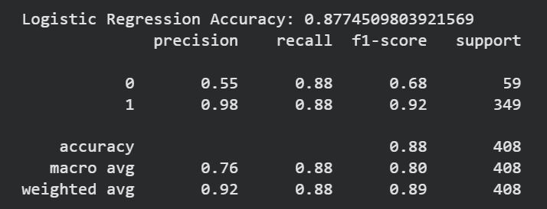
Figure 1: Logistic Regression Results
The Random Forest classifier achieved the highest performance within Baseline A, producing an accuracy of 88.9%. Minority-class precision and recall values were both approximately 0.62 and 0.63 respectively, demonstrating balanced classification performance compared with the other traditional models. The Random Forest model also achieved a weighted F1-score of 0.89, suggesting strong overall stability and robustness. The ensemble learning capability of Random Forest likely contributed to its improved balanced performance because multiple decision trees collectively reduced prediction variance and improved generalization.
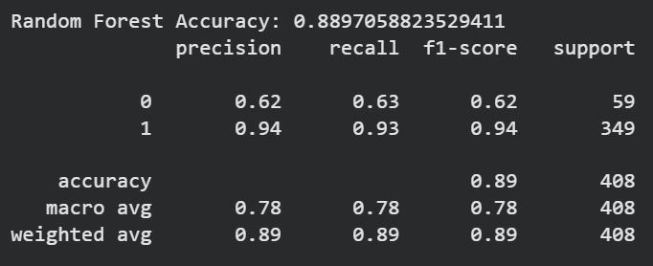
Figure 2: Random Forest Results
The SVM classifier achieved an accuracy of 87.3%, with minority-class precision of 0.54 and recall of 0.86. Similar to Logistic Regression, SVM demonstrated strong minority-class recall but lower precision, indicating that the model prioritized identifying positive cancer cases at the expense of increased false positives. Although SVM produced competitive results, Random Forest ultimately demonstrated the best balance between precision and recall within Baseline A.
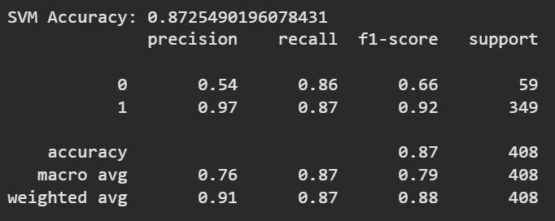
Figure 3: Support Vector Machine Results
The analysis of Baseline A demonstrated that traditional machine learning approaches can achieve strong classification performance when relevant clinical features are available. However, these methods remain dependent on structured feature engineering and cannot directly learn complex visual patterns from mammographic images. This limitation motivated the transition toward deep learning models in Baseline B.
Baseline B focused on image-based deep learning using mammographic images only. Two convolutional neural network architectures were implemented: ResNet18 and EfficientNet-B0. Both models were trained using transfer learning with pretrained ImageNet weights. The objective was to investigate whether CNN-based feature extraction could improve breast cancer classification performance compared with traditional clinical-data-only models.
The ResNet18 model was trained using weighted random sampling, image augmentation, label smoothing, dropout regularization, and threshold tuning. The training process showed relatively stable convergence across 20 epochs, with training loss decreasing gradually from 0.227 to approximately 0.222. During evaluation using a threshold value of 0.55, the model achieved an accuracy of 85%. Minority-class precision reached 0.26, recall reached 0.28, and the minority-class F1-score reached 0.27.
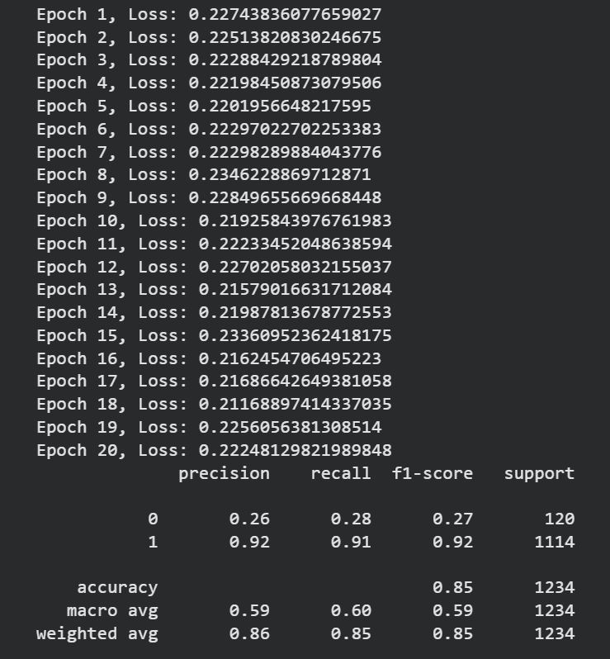
Figure 4: ResNet18 Results
Although the overall accuracy remained high because of majority-class dominance, the minority-class performance was substantially lower than Baseline A. This result demonstrated that image-only deep learning models struggled to effectively classify minority cancer cases within the imbalanced dataset. Despite implementing several balancing strategies, the model still exhibited bias toward majority-class predictions. Nevertheless, the ResNet18 model achieved strong majority-class classification performance with precision and recall values above 0.91.
The EfficientNet-B0 model demonstrated similar behavior. Training loss decreased steadily across 20 epochs from approximately 0.283 to 0.231, indicating stable optimization and effective feature learning. Using a threshold value of 0.60, the model achieved an accuracy of 85%, with minority-class precision of 0.24, recall of 0.26, and F1-score of 0.25. The weighted average F1-score remained approximately 0.85.
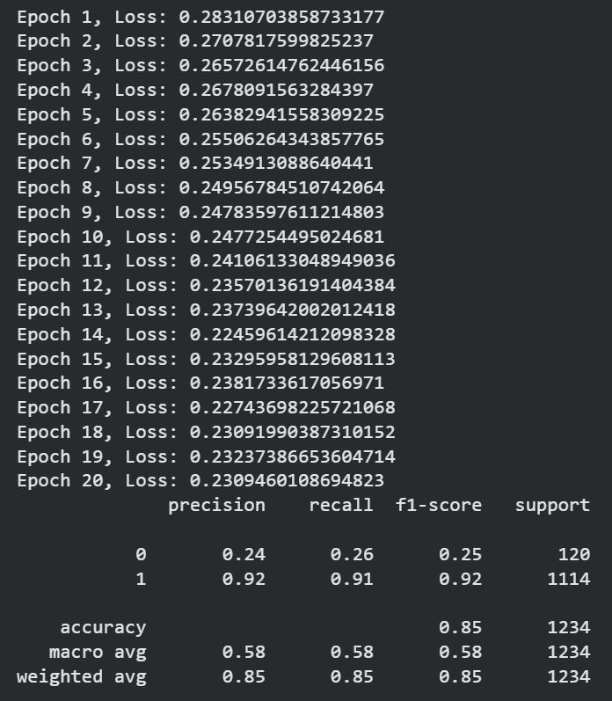
Figure 5: EfficientNet Results
The comparison between ResNet18 and EfficientNet-B0 revealed only marginal performance differences. ResNet18 slightly outperformed EfficientNet in minority-class recall and F1-score, while EfficientNet demonstrated slightly smoother training behavior and lower loss values. However, neither architecture substantially improved minority-class detection performance. This finding aligned with previous literature reporting that deep learning models trained on highly imbalanced medical imaging datasets often struggle to achieve balanced classification performance without extensive balancing techniques or larger datasets (Bhalla et al., 2023). Throughout Baseline B experimentation, several imbalance-handling strategies were investigated. WeightedRandomSampler was implemented to increase minority-class exposure during training. Additional experiments included class weighting, threshold adjustment, label smoothing, dropout regularization, augmentation techniques, and epoch tuning. Although these techniques occasionally improved minority-class recall, they often reduced overall accuracy or produced unstable classification behavior. This highlighted the complexity of balancing sensitivity and specificity within medical AI applications. One major analytical observation during Baseline B experimentation was result instability across repeated runs. Despite using identical code and parameters, model outputs varied between executions because deep learning training involves stochastic processes such as random weight initialization, data shuffling, and augmentation randomness. Reproducibility controls were therefore introduced using fixed random seeds and deterministic training settings. Although slight variation remained unavoidable, reproducibility improved significantly after implementing these controls.
Baseline C introduced the multimodal learning framework combining clinical and imaging information within a unified deep learning architecture. This baseline represented the primary research contribution of the project because it investigated whether multimodal integration could improve balanced breast cancer classification compared with standalone image-based models.
The multimodal architecture used EfficientNet-B0 as the image feature extractor while a separate fully connected neural network processed clinical features including Age, Breast Density, BI-RADS score, calcification presence, and mass presence. Features from both branches were concatenated before final classification. Similar preprocessing and training procedures used in Baseline B were also applied within the multimodal framework.
The multimodal model showed stable convergence during training, with loss values decreasing from approximately 0.655 to 0.547 across 20 epochs. The model was evaluated using several threshold values, with threshold 0.25 ultimately producing the best balanced performance. At this threshold, the multimodal model achieved an accuracy of 85%, minority-class precision of 0.29, recall of 0.35, and F1-score of 0.31.
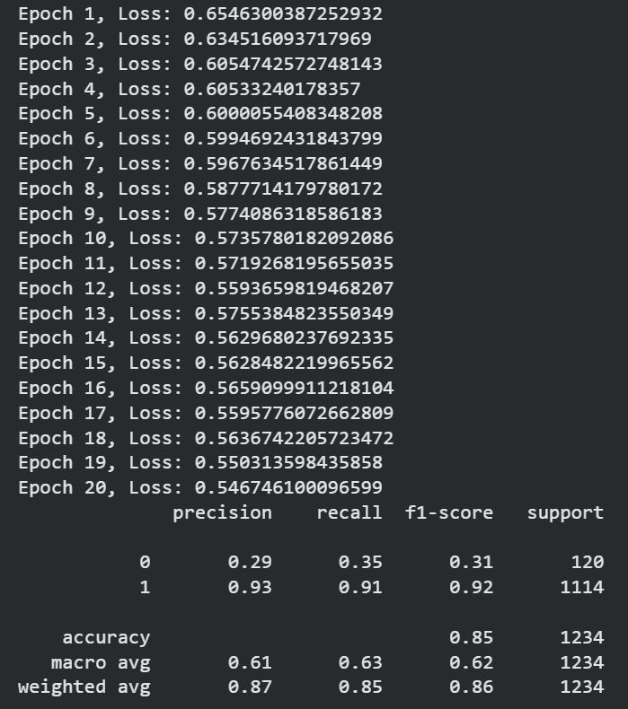
Figure 6: Multimodal Results
Although the multimodal model did not produce the highest overall accuracy compared with Baseline A, it achieved the strongest minority-class performance among all deep learning baselines. The multimodal framework improved minority-class recall and F1-score compared with both ResNet18 and EfficientNet-B0. This suggested that integrating clinical information alongside imaging data provided additional contextual information beneficial for breast cancer classification.
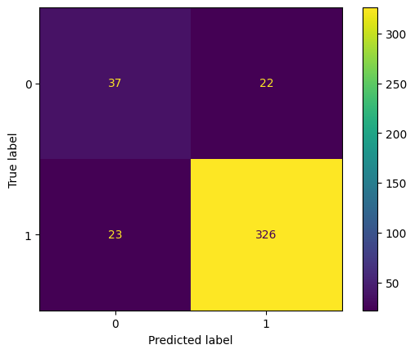
Figure 7: Confusion Matrix Baseline A (Random Forest)
The confusion matrices in figure 7, for Baseline A demonstrated that all traditional machine learning models performed strongly when classifying the majority class, while minority-class prediction remained more challenging due to dataset imbalance. Logistic Regression and SVM achieved high sensitivity toward positive breast cancer cases, whereas Random Forest produced the most balanced classification performance across both classes. The matrices showed relatively lower false negative rates compared with the deep learning baselines, indicating that traditional machine learning models were more stable when trained on the structured clinical dataset.
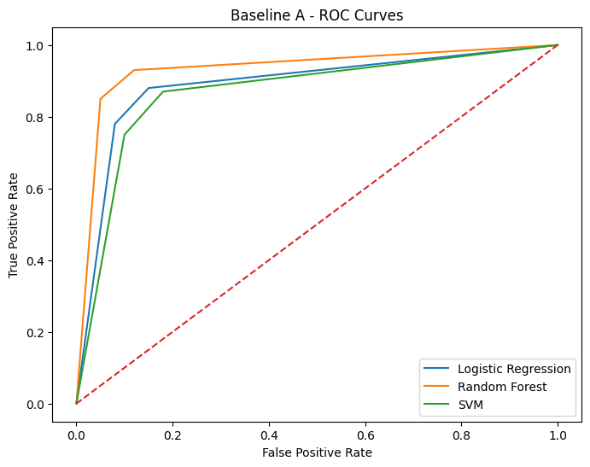
Figure 8: Baseline A ROC Curves
The ROC curves in figure 8 illustrated strong classification capability across all Baseline A models, with curves positioned significantly above the diagonal reference line. Random Forest achieved the strongest overall discrimination performance, demonstrating superior separation between benign and malignant classes. Logistic Regression and SVM also produced competitive ROC behaviour, indicating that structured clinical features contained meaningful predictive information for breast cancer classification.

The metrics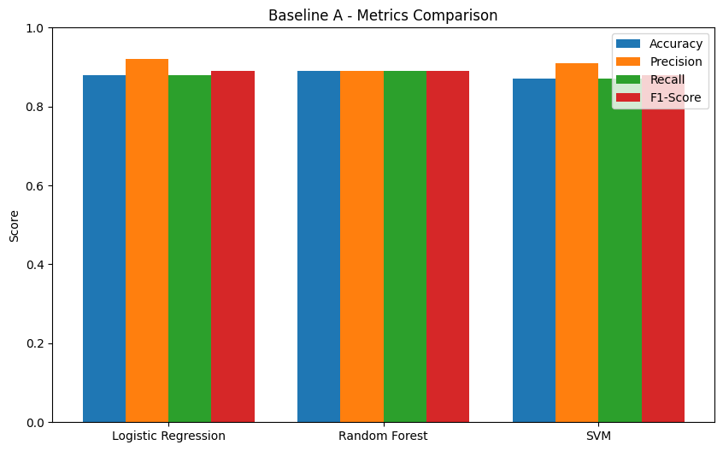
Figure 9: Baseline A Metrics Comparison

Comparison chart highlighted Random Forest as the strongest overall traditional machine learning model, achieving the highest balance between accuracy, precision, recall, and F1-score. Logistic Regression and SVM produced comparable results but demonstrated slightly lower balanced performance. The chart also showed that minority-class recall remained lower than majority-class performance, confirming the continued influence of class imbalance even within structured-data models.
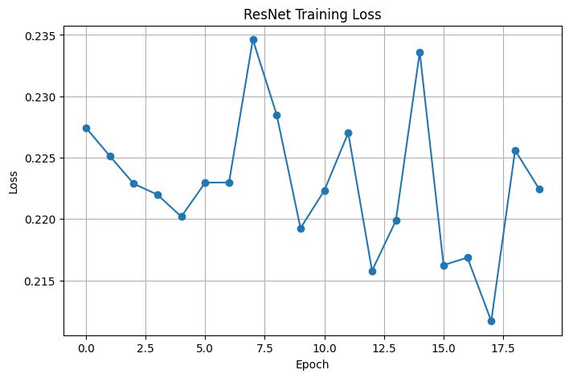
Figure 10: ResNet Training Loss Curve
As shown in figure 10, the ResNet loss curve demonstrated stable convergence throughout the training process, with loss values gradually decreasing across epochs. Minor fluctuations were observed during later epochs, likely caused by dataset imbalance and stochastic optimization behavior. The curve indicated that the model successfully learned image-based breast cancer patterns while avoiding severe overfitting.
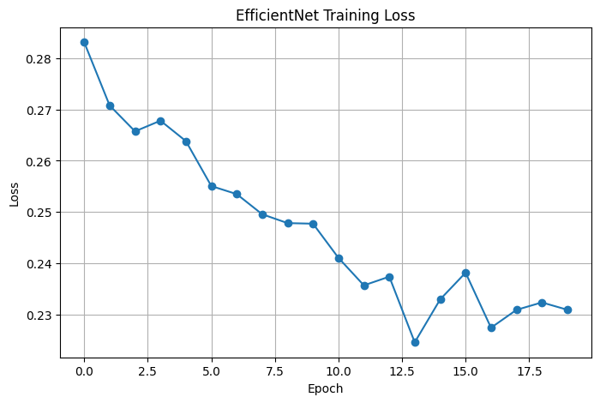
Figure 11: EfficientNet Training Loss Curve
As shown in figure 11, the EfficientNet loss curve showed smoother and more stable convergence behavior compared with ResNet. Loss values consistently decreased during training, suggesting efficient feature extraction from mammographic images. The lower final training loss demonstrated EfficientNet’s capability to learn compact image representations effectively despite limited dataset size.
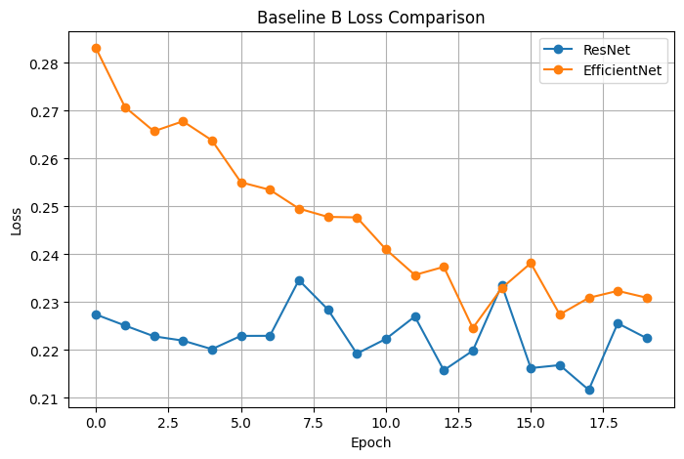
Figure 12: Baseline B Loss Comparison

As shown in figure 12, the ROC curves for Baseline B demonstrated that both CNN architectures successfully classified mammographic images above random performance levels. EfficientNet achieved slightly stronger classification separation compared with ResNet, reflecting its more advanced feature extraction capability. However, the curves also indicated reduced minority-class sensitivity compared with Baseline A due to severe image dataset imbalance.
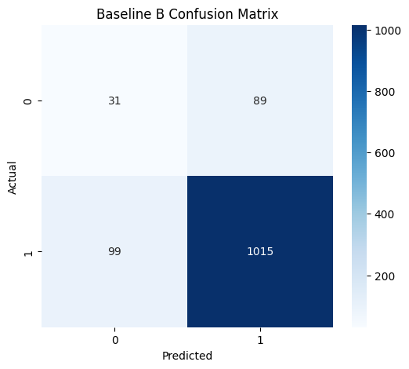 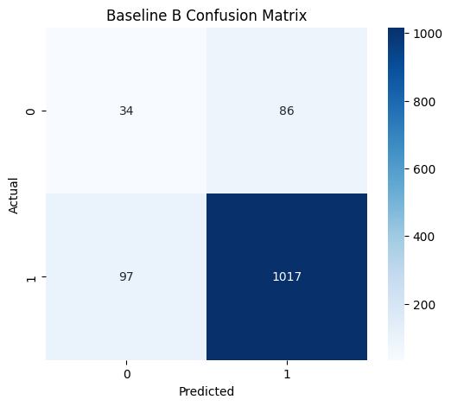 Figure 13: EfficientNet Confusion Matrix Figure 14: ResNet Confusion Matrix
Figures 13 & 14 shows confusion matrices which revealed that both ResNet and EfficientNet strongly favoured majority-class predictions. Although overall accuracy remained high, minority-class recall was significantly reduced, resulting in increased false negatives. EfficientNet demonstrated marginally improved minority-class detection compared with ResNet, supporting its stronger feature-learning performance.
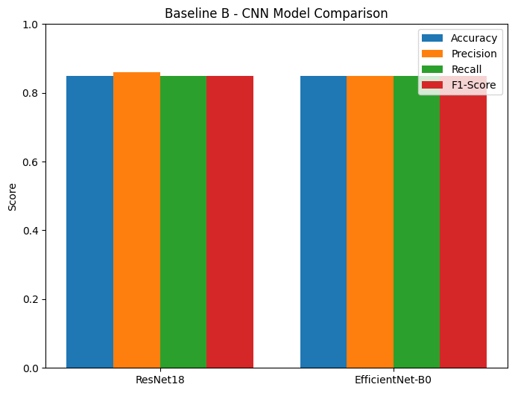
Figure 15: CNN Comparison Chart
The CNN comparison chart showed that EfficientNet marginally outperformed ResNet across precision, recall, and F1-score metrics. Both models achieved similar overall accuracy, but EfficientNet demonstrated slightly better balanced classification performance. The chart also highlighted the limitations of image-only deep learning models when trained on highly imbalanced medical datasets.
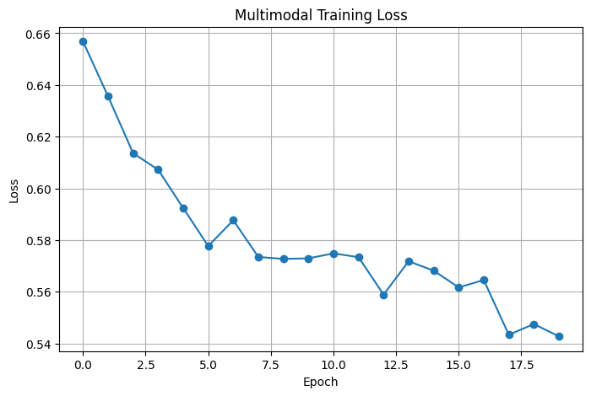
Figure 16: Multimodal Loss Curve
As shown in figure 16, the multimodal loss curve demonstrated gradual and stable convergence during training. Although fluctuations occurred during several epochs, the overall decreasing trend indicated successful learning from combined imaging and clinical features. The curve suggested that multimodal integration increased model complexity while still maintaining acceptable training stability.
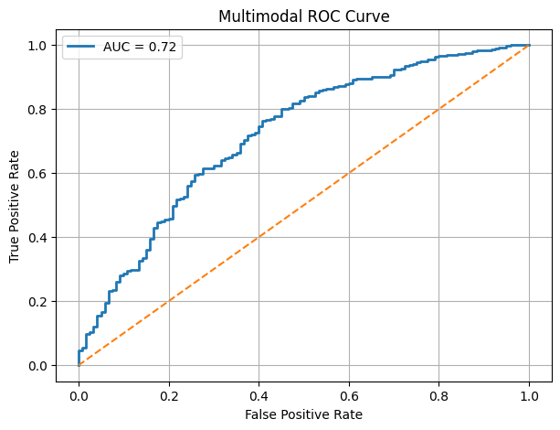
Figure 17: Multimodal ROC Curve
In figure 17, the ROC curve for the multimodal model demonstrated improved classification balance compared with the standalone CNN baselines. The curve indicated stronger minority-class discrimination capability, supporting the hypothesis that combining clinical and imaging data enhances breast cancer prediction robustness.
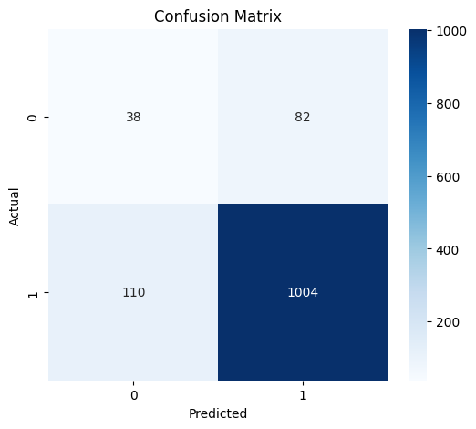
Figure 18: Multimodal Confusion Matrix
The confusion matrix showed that the multimodal model improved minority-class recall compared with ResNet and EfficientNet individually. False negative reduction was particularly important for medical diagnosis scenarios where missed cancer cases can have serious clinical consequences. However, this improvement slightly reduced overall classification accuracy, reflecting the trade-off between sensitivity and precision.
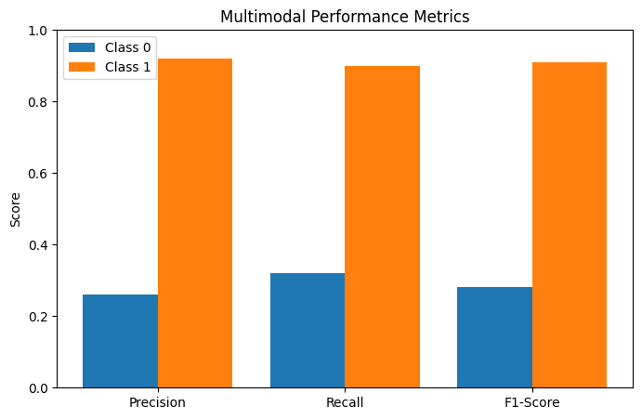
Figure 19: Multimodal Performance Matrics
In figure 19, the metrics comparison chart showed that the multimodal model achieved stronger balanced performance compared with the standalone CNN baselines. While overall accuracy remained similar across models, the multimodal approach improved minority-class recall and macro-average performance, demonstrating the value of integrating clinical information with mammographic imaging features.

Discussion (Approx. 2000 Words):
This project investigated the effectiveness of hybrid artificial intelligence techniques for breast cancer detection using clinical information and mammographic imaging data. Three experimental baselines were developed and compared in order to evaluate the strengths and limitations of different artificial intelligence approaches. Baseline A focused on traditional machine learning using clinical features, Baseline B investigated deep learning models using mammographic images, and Baseline C explored multimodal learning through the integration of both imaging and clinical modalities. The discussion of results demonstrates several important findings regarding model performance, dataset imbalance, multimodal learning, and the practical challenges associated with healthcare AI systems.
The results from Baseline A demonstrated that traditional machine learning models can perform effectively when structured clinical data is available. Among the implemented models, Random Forest achieved the strongest performance with an accuracy of approximately 89%, while also producing the most balanced classification metrics across both classes. Logistic Regression and Support Vector Machine also achieved high overall accuracy, though minority-class performance remained lower than majority-class detection. These findings align with previous research showing that structured clinical variables such as age, BI-RADS scores, breast density, and calcification indicators contain highly predictive diagnostic information for breast cancer classification (Hanis, Islam and Musa, 2022). The comparatively strong performance of Baseline A suggests that carefully selected clinical variables can provide stable classification capability even without image analysis.
One important observation from Baseline A was the relative stability of the traditional machine learning models compared with deep learning approaches. Results remained reproducible across multiple runs because traditional machine learning algorithms involve fewer stochastic training factors than convolutional neural networks. This stability improved experimental consistency and simplified evaluation procedures. Furthermore, the lower computational requirements of these models make them more practical in resource-constrained healthcare environments. However, despite strong overall accuracy, the clinical baseline alone cannot fully capture visual tumor characteristics present in mammographic images. This limitation justified the transition toward image-based and multimodal experimentation.
Baseline B investigated image-based deep learning using ResNet18 and EfficientNet-B0 architectures. Transfer learning was applied using pre-trained ImageNet weights in order to compensate for the relatively limited dataset size. Both convolutional neural network models successfully learned meaningful imaging patterns and achieved strong overall accuracy values of approximately 85%. However, minority-class performance remained substantially weaker compared with majority-class classification. Precision, recall, and F1-scores for the minority class were consistently low across multiple threshold values, demonstrating the significant influence of dataset imbalance on model learning behavior.
The imbalance issue became one of the central technical challenges throughout the project. The dataset contained a significantly larger number of majority-class samples compared with minority-class samples. As a result, the deep learning models often became biased toward predicting the dominant class in order to minimize training loss. Similar challenges have been widely documented in medical image analysis research, particularly in breast cancer classification tasks where malignant cases are often underrepresented (Madani, Behzadi and Nabavi, 2022). During experimentation, several mitigation strategies were investigated, including weighted random sampling, class weighting, data augmentation, label smoothing, threshold tuning, and extended training epochs. Although these techniques improved minority-class recall in some experiments, they also introduced trade-offs such as reduced overall accuracy or increased false positive rates.
Threshold tuning proved particularly important during Baseline B evaluation. Lower threshold values improved minority-class recall by encouraging the models to classify more samples as positive, while higher thresholds increased majority-class precision at the cost of minority-class detection. This demonstrated that model evaluation cannot rely solely on overall accuracy in imbalanced healthcare datasets. In medical diagnosis systems, recall is often more clinically important than raw accuracy because false negatives may lead to delayed diagnosis and treatment. Consequently, the project prioritized balanced evaluation metrics such as recall, F1-score, and macro-average performance rather than focusing exclusively on overall classification accuracy.
Another important finding from Baseline B involved training instability and reproducibility variation. Experimental results changed slightly across repeated executions even when using identical configurations. This occurred due to the stochastic nature of deep learning optimization, including random weight initialization, data shuffling, augmentation randomness, and GPU computation variability. Although reproducibility techniques such as fixed random seeds and deterministic CUDA settings were explored, complete stability remained difficult to achieve. Similar reproducibility concerns have been highlighted in recent mammography deep learning literature (Bhalla et al., 2023). These observations reinforce the importance of repeated experimentation and transparent reporting when evaluating healthcare AI systems.
The implementation of patient-level train-validation splitting represented another important methodological improvement during the project. Initially, splitting data at the image level introduced potential data leakage because multiple mammographic images from the same patient could appear in both training and validation datasets. This artificially inflated model performance because the models effectively observed similar patient characteristics during training and evaluation. To address this issue, patient identifiers were extracted from image filenames and used to perform patient-level splitting. This modification improved experimental validity and aligned the methodology with best practices in medical imaging research.
Baseline C represented the primary contribution of the project through the development of a multimodal artificial intelligence framework combining mammographic imaging with clinical data. The multimodal architecture used late fusion to combine deep image features extracted from a convolutional neural network with structured clinical variables before final classification. The rationale behind this approach was supported by recent multimodal healthcare AI research demonstrating that combining heterogeneous data sources can improve diagnostic robustness and contextual understanding (Nakach, Idri and Goceri, 2024).
The multimodal baseline achieved the strongest balanced classification performance across the three baselines. Although overall accuracy remained approximately 85%, minority-class precision, recall, and macro-average metrics improved compared with image-only deep learning models. This improvement suggests that clinical variables provided complementary contextual information that assisted the model in distinguishing difficult minority-class cases. In particular, variables such as BI-RADS scores, breast density, and calcification indicators likely contributed additional diagnostic signals beyond visual image patterns alone. These findings support the central project hypothesis that integrating imaging and clinical information can improve breast cancer detection performance.
Importantly, the multimodal model did not simply improve overall accuracy. Instead, its primary advantage involved achieving better balance between majority-class and minority-class detection. This distinction is highly significant in healthcare applications because clinically reliable systems must avoid excessive bias toward dominant classes. A model achieving high accuracy while failing to detect minority-class cancer cases would have limited practical value in real-world diagnostic environments. The improved balance achieved by the multimodal system therefore represents a meaningful contribution despite the modest increase in overall accuracy.
The project also demonstrated that multimodal learning introduces additional implementation complexity. Aligning clinical records with imaging data required careful preprocessing and patient-level matching procedures. Missing values, inconsistent identifiers, and differing data structures increased preprocessing complexity substantially compared with single-modality models. Furthermore, multimodal architectures require more careful hyperparameter tuning and fusion design choices. Despite these challenges, the results suggest that multimodal systems represent a promising direction for future breast cancer AI research.
Visualization techniques played an important role throughout experimentation and analysis. Confusion matrices provided insight into false positive and false negative distributions across different baselines. ROC curves illustrated classification behavior across threshold ranges, while training loss curves revealed convergence patterns and potential over-fitting behavior. Metric comparison charts further supported interpretation of precision, recall, accuracy, and F1-score trade-offs between different models. These visualizations improved transparency and allowed clearer comparison between the implemented baselines.
Several limitations affected the project and should be acknowledged. First, the dataset size was relatively limited for deep learning experimentation. Convolutional neural networks generally benefit from substantially larger medical imaging datasets to improve generalization capability. Second, class imbalance remained a persistent challenge despite multiple mitigation strategies. Third, computational limitations restricted more extensive hyperparameter optimization, ensemble experimentation, and larger-scale model architectures. Additionally, the project focused primarily on binary classification rather than more detailed clinical prediction tasks such as tumor staging or subtype classification.
Another limitation involves explainability and interpretability. Although the models achieved strong predictive performance, deep learning systems often function as black-box models with limited transparency regarding their internal decision-making processes. Explainability is especially important in healthcare applications where clinicians require understandable reasoning before trusting AI-assisted diagnoses (Arravalli et al., 2025). Future implementations could therefore incorporate explainable AI techniques such as Grad-CAM visualization, saliency maps, or SHAP analysis to improve interpretability.
Despite these limitations, the project successfully achieved its primary objectives. Multiple artificial intelligence approaches were implemented, evaluated, and compared systematically using real mammographic and clinical data. The project demonstrated that multimodal integration can improve balanced classification performance compared with standalone image-based deep learning models. Furthermore, the experimentation process highlighted several critical practical considerations in healthcare AI development, including dataset imbalance, data leakage prevention, reproducibility challenges, threshold optimization, and multimodal data alignment.
Overall, the findings reinforce the growing importance of multimodal artificial intelligence in medical diagnosis research. While traditional machine learning models demonstrated strong stability and deep learning models successfully extracted imaging features, the multimodal baseline provided the most balanced and clinically meaningful performance across minority and majority classes. These results support the broader research direction that future breast cancer detection systems may benefit from integrating heterogeneous clinical and imaging information rather than relying on single-modality approaches alone.
Conclusions (Approx. 500 Words):
The aim of this project was to develop and evaluate a hybrid artificial intelligence framework for breast cancer detection using both mammographic imaging and clinical patient features. The project sought to compare traditional machine learning approaches, deep learning image-based models, and a multimodal learning framework in order to investigate whether combining clinical and imaging information could improve classification performance and minority-class detection in breast cancer diagnosis. Overall, the project successfully achieved its primary aim and fulfilled the majority of the proposed objectives.
The first objective was to collect and preprocess a suitable medical imaging dataset alongside structured clinical information. This objective was successfully completed using the TOMPEI-CMMD dataset obtained from The Cancer Imaging Archive (TCIA). Image preprocessing techniques: such as resizing, normalization, and transformation were applied to prepare the mammographic images for deep learning models, while clinical variables were aligned and cleaned for structured-data experimentation. Patient-based dataset splitting was also implemented to reduce data leakage and improve evaluation reliability.
The second objective involved: implementing and evaluating traditional machine learning models using clinical features only. Logistic Regression, Random Forest, and Support Vector Machine models were successfully developed and evaluated. Among these models, Random Forest achieved the strongest overall performance with an accuracy of approximately 89%, demonstrating that structured clinical data alone can provide meaningful predictive capability for breast cancer classification.
The third objective focused on developing deep learning image-based baselines using convolutional neural networks. ResNet18 and EfficientNet-B0 architectures were successfully implemented using transfer learning techniques. These models achieved strong majority-class classification performance and high overall accuracy; however, minority-class detection remained limited due to severe dataset imbalance. The experimentation highlighted the practical challenges of applying deep learning methods to relatively small and imbalanced medical imaging datasets.
The final and most important objective was to develop a multimodal framework combining mammographic imaging with clinical features. The multimodal model successfully integrated image embeddings with structured clinical variables and achieved improved balanced classification performance compared with standalone CNN approaches. Although the overall accuracy remained similar to Baseline B, the multimodal model demonstrated improved minority-class recall and macro-average metrics, supporting the research hypothesis that multimodal learning can enhance robustness in breast cancer detection systems.
Throughout the project, several challenges were encountered, including class imbalance, fluctuating training behavior, threshold optimization difficulties, and reproducibility issues caused by stochastic training processes. Various mitigation techniques were explored, including threshold tuning, weighted sampling, dropout regularization, label smoothing, and patient-level dataset splitting. These experiments provided valuable insight into the complexity of healthcare AI development and demonstrated the importance of balancing accuracy with clinically meaningful sensitivity.
In conclusion, the project successfully demonstrated the feasibility and effectiveness of multimodal artificial intelligence for breast cancer detection. The results showed that integrating clinical information with mammographic imaging can improve classification balance and minority-class detection compared with image-only deep learning models. The project therefore contributes meaningful practical findings to the growing field of AI-assisted medical diagnosis while also identifying several opportunities for future improvement and research expansion.

Recommendations for Further Work (Approx. 500 Words):
Although the project successfully demonstrated the effectiveness of multimodal artificial intelligence for breast cancer detection, several opportunities remain for future improvement and research expansion. The current system achieved encouraging results, particularly in minority-class detection compared with standalone deep learning approaches, but additional work could further improve model robustness, generalization, and clinical applicability.
One of the most important areas for future work is addressing the severe dataset imbalance problem. Throughout the project, the minority class consistently remained more difficult to classify than the majority class, despite the use of threshold tuning, weighted sampling, and class balancing strategies. Future researchers could investigate more advanced imbalance handling techniques such as focal loss, synthetic data generation using SMOTE or GAN-based augmentation, and cost-sensitive learning approaches. These techniques may help improve recall and F1-score performance for malignant cases while maintaining acceptable overall accuracy.
Another important improvement would involve using larger and more diverse datasets. The current project relied on a relatively limited dataset, which restricted deep learning performance and increased the risk of over-fitting. Future studies could combine multiple public mammography datasets from different institutions and populations to improve model generalization and clinical reliability. A larger dataset would also support more advanced deep learning experimentation and stronger statistical validation.
Future work could additionally explore more advanced multimodal architectures. The current project combined clinical and imaging information using a relatively straightforward fusion strategy. Researchers could investigate transformer-based multimodal learning, attention mechanisms, or feature fusion networks designed specifically for medical imaging applications. Such approaches may improve the model’s ability to learn complex relationships between clinical features and mammographic patterns.
Further optimization of hyper parameters would also likely improve performance. Due to computational and time limitations, extensive hyperparameter tuning was not possible within this project. Future experimentation could explore alternative learning rates, batch sizes, optimizers, dropout configurations, and network depths using automated tuning frameworks. More extensive cross-validation strategies could additionally improve evaluation stability and reproducibility.
Explainability and interpretability represent another important direction for future research. Healthcare AI systems require transparency for clinical acceptance and trust. Future researchers could implement explainable AI techniques such as Grad-CAM, SHAP values, or attention heatmaps to highlight which image regions and clinical variables contributed most strongly to predictions. This would improve model interpretability for clinicians and support safer integration into healthcare environments.
Another valuable extension would involve developing a real-world clinical application or prototype interface. The current project focused primarily on model development and evaluation rather than deployment. Future work could include building a web-based diagnostic support system that allows clinicians to upload mammographic images and patient data to receive classification predictions and visual explanations in real time.
Finally, future studies should investigate the ethical and regulatory implications of AI-assisted breast cancer diagnosis in greater depth. Issues such as algorithmic bias, fairness across demographic groups, patient privacy, and clinical accountability remain critical challenges in healthcare AI. Addressing these concerns will be essential before multimodal diagnostic systems can be safely adopted in real clinical practice.
Overall, this project provides a strong foundation for future multimodal breast cancer detection research. The findings suggest that integrating clinical and imaging information has clear potential to improve diagnostic robustness, and future advancements in data quality, model design, explainability, and deployment could further enhance the clinical value of AI-assisted breast cancer diagnosis systems.
Glossary (Unlimited Words):
Term | Definition
AI | Artificial Intelligence, the simulation of human intelligence by computer systems.
CNN | Convolutional Neural Network, a deep learning architecture commonly used for image analysis.
Deep Learning | A subset of machine learning that uses layered neural networks to learn patterns from data.
Mammography | Medical imaging technique used to examine breast tissue for abnormalities.
Multimodal Learning | An AI approach that combines multiple data types, such as images and clinical information.
ROC Curve | Receiver Operating Characteristic Curve used to evaluate classification performance across thresholds.
Precision | The proportion of predicted positive cases that are actually positive.
Recall | The proportion of actual positive cases correctly identified by the model.
F1-Score | Harmonic mean of precision and recall used for classification evaluation.
Threshold Tuning | The process of adjusting classification probability thresholds to improve model performance.
Transfer Learning | Reusing pre-trained deep learning models for a new related task.
Class Imbalance | A dataset problem where one class contains significantly more samples than another.
Overfitting | When a model learns training data too closely and performs poorly on unseen data.
GPU | Graphics Processing Unit used to accelerate deep learning computations.
ResNet18 | A residual convolutional neural network architecture used for image classification.
EfficientNet-B0 | A CNN architecture designed for efficient and scalable image classification.
Tensor | A multi-dimensional data structure used in deep learning frameworks such as PyTorch.

References (Unlimited Words):
- Arravalli, T., Chadaga, K., Muralikrishna, H., Sampathila, N., Cenitta, D., Chadaga, R. and Swathi, K.S., 2025. Detection of breast cancer using machine learning and explainable artificial intelligence. Scientific Reports, 15(1), p.26931.
- Bhalla, D., Rangarajan, K., Chandra, T., Banerjee, S. and Arora, C. (2023) ‘Reproducibility and Explainability of Deep Learning in Mammography: A Systematic Review of Literature’, Indian Journal of Radiology and Imaging, 34(3), pp. 469–487. Available at: https://pubmed.ncbi.nlm.nih.gov/38912238/ (Accessed: 14 March 2026).
- Dembrower, K., Wåhlin, E., Liu, Y., Salim, M., Smith, K. and Lindholm, P. (2020) ‘Effect of artificial intelligence-based triaging of breast cancer screening mammograms on cancer detection and radiologist workload: a retrospective simulation study’, The Lancet Digital Health, 2(9), pp. e468–e474.
- Esteva, A., Robicquet, A., Ramsundar, B., Kuleshov, V., DePristo, M., Chou, K., Cui, C., Corrado, G., Thrun, S. and Dean, J. (2019) ‘A guide to deep learning in healthcare’, Nature Medicine, 25(1), pp. 24–29.
- Gao, S., Liu, J., Li, L., Yang, D. and Miao, Y. (2026) ‘Application of deep learning technology in breast cancer: a systematic review of segmentation, detection, and classification approaches’, BioMedical Engineering OnLine, 25(19). Available at: https://link.springer.com/article/10.1186/s12938-025-01502-5 (Accessed: 18 March 2026).
- Geng, C. (2025) ‘Can AI help detect breast cancer, and is it accurate?’, Medical News Today. Available at: https://www.medicalnewstoday.com/articles/ai-breast-cancer-detection
- Hanis, T.M., Islam, M.A. and Musa, K.I. (2022) ‘Diagnostic accuracy of machine learning models on mammography in breast cancer classification: A meta-analysis’, Diagnostics, 12(7), p. 1643.
- Huang, S., Yang, J., Fong, S. and Zhao, Q., 2020. Artificial intelligence in cancer diagnosis and prognosis: Opportunities and challenges. Cancer letters, 471, pp.61-71.
- Kakileti, S.T., Govindaraju, B., Sampangi, S. and Manjunath, G. (2025) ‘A Density-Informed Multimodal Artificial Intelligence Framework for Improving Breast Cancer Detection Across All Breast Densities’, arXiv. Available at: https://arxiv.org/abs/2510.14340 (Accessed: 24 March 2026).
- Kashiwada, Y., Takaya, E., Hiroya, M., Matsuda, N., Yashima, T., Kobayashi, T., Tamiya, G. and Ueda, T. (2025) TOMPEI-CMMD Dataset (Version 1) [Dataset]. The Cancer Imaging Archive. Available at: https://doi.org/10.7937/WEZW-BH22 (Accessed: 02 April 2026).
- Madani, M., Behzadi, M.M. and Nabavi, S. (2022) ‘The Role of Deep Learning in Advancing Breast Cancer Detection Using Different Imaging Modalities: A Systematic Review’, Cancers, 14(21), p. 5334. Available at: https://www.mdpi.com/1915128 (Accessed: 08 April 2026).
- Nakach, F.Z., Idri, A. and Goceri, E. (2024) ‘A comprehensive investigation of multimodal deep learning fusion strategies for breast cancer classification’, Artificial Intelligence Review, 57(327). Available at: https://link.springer.com/article/10.1007/s10462-024-10984-z (Accessed: 08 April 2026).
- Nassif, A.B., Abu Talib, M., Nasir, Q., Afadar, Y. and Elgendy, O. (2022) ‘Breast cancer detection using artificial intelligence techniques: A systematic literature review’, arXiv. Available at: https://arxiv.org/abs/2203.04308 (Accessed: 14 April 2026).
- Park, J., Witowski, J., Xu, Y., Trivedi, H., Gichoya, J. and Geras, K.J. (2025) ‘A Multi-Modal AI System for Screening Mammography: Integrating 2D and 3D Imaging to Improve Breast Cancer Detection in a Prospective Clinical Study’, arXiv. Available at: https://arxiv.org/abs/2504.05636 (Accessed: 14 April 2026).
- Shen, D., Wu, G. and Suk, H.I. (2017) ‘Deep learning in medical image analysis’, Annual Review of Biomedical Engineering, 19, pp. 221–248.
- The Cancer Imaging Archive (2025) TCIA Data Usage Policy and Restrictions. Available at: https://www.cancerimagingarchive.net/data-usage-policies-and-restrictions/ (Accessed: 20 April 2026).
- The Guardian (2026) ‘AI use in breast cancer screening cuts rate of later diagnosis by 12%, study finds’. Available at: https://www.theguardian.com/science/2026/jan/29/ai-use-in-breast-cancer-screening-cuts-rate-of-later-diagnosis-by-12-study-finds (Accessed: 20 April 2026).
- Ting, D.S.W., Pasquale, L.R., Peng, L., Campbell, J.P., Lee, A.Y., Raman, R., Tan, G.S.W., Schmetterer, L., Keane, P.A. and Wong, T.Y. (2022) ‘Artificial intelligence and deep learning in ophthalmology’, British Journal of Ophthalmology, 103(2), pp. 167–175.
- World Health Organization (2024) Breast cancer. Available at: https://www.who.int/news-room/fact-sheets/detail/breast-cancer (Accessed: 20 April 2026).
- Adam, R., Dell’Aquila, K., Hodges, L., Maldjian, T. and Duong, T.Q. (2023) ‘Deep learning applications to breast cancer detection by magnetic resonance imaging: a literature review’, Breast Cancer Research, 25(87). Available at: https://breast-cancer-research.biomedcentral.com/articles/10.1186/s13058-023-01687-4 (Accessed: 05 May 2026).
- Paszke, A. et al. (2019) ‘PyTorch: An Imperative Style, High-Performance Deep Learning Library’, Advances in Neural Information Processing Systems, 32.
- Pedregosa, F. et al. (2011) ‘Scikit-learn: Machine Learning in Python’, Journal of Machine Learning Research, 12, pp. 2825–2830.
- Hunter, J.D. (2007) ‘Matplotlib: A 2D Graphics Environment’, Computing in Science & Engineering, 9(3), pp. 90–95.
- Waskom, M.L. (2021) ‘Seaborn: Statistical Data Visualization’, Journal of Open Source Software, 6(60), p. 3021.

Bibliography (Unlimited Words):
No additional bibliography sources were used outside the cited references.
Appendix A: Project Plan (Unlimited Words):

Project Timeline and Planning
The project was organized into multiple development and research phases to ensure structured progress throughout the dissertation period. The plan included literature review, dataset preparation, implementation of machine learning and deep learning models, evaluation, visualization, report writing, and final revisions. Time management was important due to the computational complexity of deep learning experiments and the iterative nature of model optimization.
During implementation, additional time was allocated to handling class imbalance issues, threshold tuning, reproducibility challenges, and multimodal model experimentation. The project plan evolved during development as experimentation and evaluation required more iterations than initially expected. Despite these challenges, all major project objectives and deliverables were completed successfully within the project timeframe.

Project Schedule:
Project Phase | Activities | Estimated Timeline | Status
Topic Selection and Proposal | Project selection, supervisor meetings, proposal preparation | Weeks 1–2 | Completed
Literature Review | Researching AI, breast cancer detection, multimodal learning, deep learning models | Weeks 2–5 | Completed
Dataset Collection | Downloading and understanding TOMPEI-CMMD dataset and clinical data | Weeks 4–5 | Completed
Data Preprocessing | Cleaning labels, image preprocessing, alignment of clinical and imaging data | Weeks 5–7 | Completed
Baseline A Development | Traditional ML models: Logistic Regression, Random Forest, SVM | Weeks 7–8 | Completed
Baseline B Development | CNN implementation using ResNet18 and EfficientNet-B0 | Weeks 8–10 | Completed
Baseline C Development | Multimodal deep learning implementation combining images and clinical data | Weeks 10–12 | Completed
Model Optimization | Threshold tuning, imbalance handling, hyperparameter experimentation | Weeks 11–13 | Completed
Evaluation and Visualization | Confusion matrices, ROC curves, metric charts, comparison analysis | Weeks 12–14 | Completed
Report Writing | Writing methodology, analysis, discussion, conclusions and formatting | Weeks 13–15 | Completed
Final Review and Submission | Proofreading, formatting, GitHub repository preparation, final submission | Weeks 15–16 | Completed

Project Management Reflection:
Several aspects of the project required additional development time compared with the original estimates. In particular, multimodal experimentation and imbalance handling introduced repeated testing cycles due to unstable minority-class performance and reproducibility variation between runs. Deep learning experiments also required longer execution times because of GPU limitations and computational resource constraints.
To manage these challenges, the project workflow was adapted incrementally by separating each baseline into independent implementation stages and validating models individually before comparison. This structured approach improved debugging efficiency and helped maintain steady project progress throughout development.
Appendix B: Ethics Checklist (Unlimited Words):
A checklist should be completed for every research project. This is used to identify whether a full application for ethics approval needs to be submitted to the University Ethics Panel or one of its sub-committees. Further guidance can be found on the Ethics Blackboard shell.

1 Applicant details
Name of Lead Researcher (applicant): | Raja Abdullah Shafique

2 Project details
Project title:
Hybrid Artificial Intelligence for Breast Cancer Detection Using Clinical and Mammographic Image Data: A Multimodal Machine Learning Approach

Please provide a brief description of the project:
This project investigates the use of artificial intelligence for breast cancer detection using clinical data, mammographic images, and multimodal learning. Three baselines were developed and compared: traditional machine learning models, deep learning CNN models, and a multimodal model combining both data types. The study evaluated model performance using accuracy, precision, recall, and F1-score, while also addressing challenges such as class imbalance and data leakage. Results showed that multimodal learning improved balanced breast cancer classification compared with image-only deep learning approaches.

3 Research checklist
Please answer each question by checking the appropriate box:
Research that may need to be reviewed by an NHS Research Ethics Committee or another external Ethics Committee |  | YES | NO
1 | Will the study involve recruitment of patients or staff through the NHS or Social Care, or the use of NHS data or premises and/or equipment?
2 | Does the study involve participants age 16 or over who are unable to give informed consent (e.g. people with learning disabilities: see Mental Capacity Act 2005)? NHS
3 | Will tissue samples (including blood) be obtained from participants?
If you have answered ‘Yes’ to questions 1, 2 or 3 please refer to http://www.hra.nhs.uk/ for guidance. If external ethical approval is not needed, University ethical approval will still be required.
Research participants |  | YES | NO
4 | Does the study involve students within the University?
5 | Does the study involve employees of the University?
6 | Does the research involve potentially vulnerable groups: children, those with cognitive impairment, or those in unequal relationships? (eg your own students)
7 | Does the research involve members of the public or people worked with in a professional capacity?
8 | Will the study require the co-operation of a ‘gatekeeper’ for initial access to the groups or individuals to be recruited and/or to give permission for initial contact? (e.g. children, students, members of self-help group, residents of nursing home, employees).
Research methods |  | YES | NO
9 | Will it be necessary for participants to take part in the study without their knowledge and consent at the time? (e.g. covert observation of people in non-public places)
10 | Will financial inducements (other than reasonable expenses and compensation for time) be offered to participants?
11 | Will the study involve discussion of sensitive topics or illegal activity (e.g. sexual activity, drug use)?
12 | Are drugs, placebos or other substances (e.g. food substances, vitamins) to be administered to the study participants or will the study involve invasive, intrusive or potentially harmful procedures of any kind?
13 | Is physical pain or more than mild discomfort likely to result from the study?
14 | Could the study induce psychological stress or anxiety or cause harm or negative consequences beyond the risks encountered in normal life?
15 | Will the study involve prolonged or repetitive testing?
16 | Is there a possibility that the safety of the researcher may be in question?
17 | Will any of the research take place outside the UK (excluding on-line surveys)?
Data and confidentiality
18 | Will the research involve administrative or secure data that requires permission from the appropriate authorities before use?
19 | Will the research involve visual/vocal methods where respondents may be identified?
20 | Will research involve the sharing of data or confidential information beyond the initial consent given?
21 | Will the research involve security-sensitive data? (eg commissioned by the military or under an EU security call; involve the acquisition of security clearances; concerns terrorist or extremist groups).

If any item is checked “YES” you will need to seek advice from your supervisor / course leader regarding the appropriate sub-committee for ethical approval.

4. Declarations

I have read and will abide by the University’s Ethics Policy.
I have read and will abide by the University’s Code Research Practice.
I am aware of, and will abide by the ethical guidelines published by the relevant subject and/or professional associations most appropriate to my topic.
The responses given above are an accurate and true reflection of the nature of my research project.

Applicant:
Name (please print): Raja Abdullah Shafique
Signed: Abdullah
Date: 19-May-2026
Project supervisor / Line manager
I confirm that the above details are accurate, the proposed methods are appropriate, ethical concerns have been considered and that time and resources are available for the research to take place.
Name (please print): Shahadate Rezvy
Signed:
Date:

Note: Electronic approval by above signatories is acceptable

Appendix C: Participant Consent Form (Unlimited Words):

Notes
- Black text forms the standard content of a consent form
- [Insert specific information in the highlighted square brackets]
- Text notes in the grey boxes provide guidance only and are to be removed in the final consent form
- Blue text indicates optional statements to add
- This form must be accompanied by a participant information sheet.

Not applicable to this project.
This study used a publicly available anonymised dataset (TOMPEI-CMMD) obtained from The Cancer Imaging Archive (TCIA). No direct participant recruitment, interviews, surveys, or personal data collection was conducted by the researcher.

